Email:loverealmglobal@yahoo.com

Your Ref: Date: {{dateDay}}{{daySuffix}} {{dateMonthUpper}}, {{dateYear}}

WARRANTY
This limited warranty of LOVEREALM LIMITED applies to all Equipment supplied under the said contract. All products are guaranteed to be new and free of defective materials and workmanship, and are covered under warranty subject to the following terms and conditions. Unless stated otherwise as an Extraordinary Warranty Period, the Warranty Period for all equipment supplied by Loverealm Limited.is valid for One year from the date of shipment.

During the warranty period, The Engineering team of Loverealm Limited will repair or replace defective parts with new parts in accordance to the terms, limitations and conditions.

This is the sole Warranty provided by Loverealm Limited.


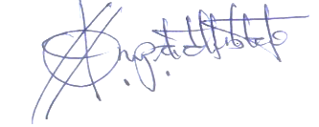

…………………………
NANA YAW AMPADU

MANAGING DIRECTOR


